Cyber Space Odyssey

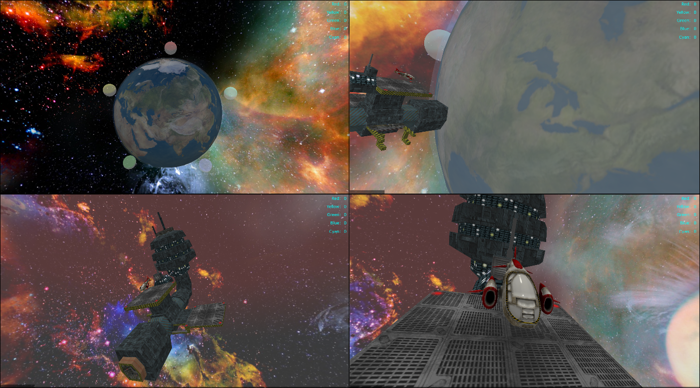

At AFIT, we have created a new Advanced Cyber Education (ACE) Lab to teach Cyber & Network Security through a hands-on 3D Virtual World-based scenario. This lab spans the gamut of cyber operations -- from physical hardware, to state-of-the-art network tools, to distributed 3D Virtual Worlds. Teams must employ computer networking tactics at all these levels to solve a mystery cyber scenario. This futuristic environment places AFIT’s campus in Earth’s orbit as a set of space stations. Each team must navigate their space ship to different stations where they conduct cyber surveillance to collect clues, capture network traffic, inject network messages, and attempt to hijack opposing teams’ spacecraft.

This simulation environment extends beyond cyber training – autonomy, navigation, reconnaissance, remote sensing, and other areas have utilized this technology to increase human cognition and ability. We plan to further extend this VR technology to include additional training scenarios and deploy this technology to a broader Air Force audience.

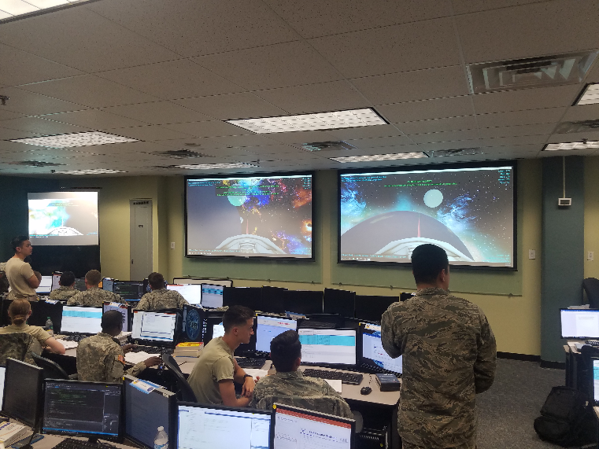
Linked below, is an enticing (fun) YouTube video detailing the cyber simulation: https://www.youtube.com/watch?v=fn9QNoVsnZI (PA Approved 88ABW-2017-3899)

In terms of “shipping” this lab for demo, the full game requires 6 wirelessly networked laptops and an Access Point; however, a demo showing off its functionality could easily be done using only 2 laptops.

A complete listing of 30+ videos using this technology is available at:
https://www.youtube.com/user/nykl1206/videos

Dr. Scott Nykl, AFIT
AFIT/ENG
B642 R203, x4395, scott.nykl@afit.edu

